Summary of 2019 West Kootenay FIDS Permanent Sample Plots

Background
In 2009 nine PSP’s formerly monitored by the Forest Insect and Disease Survey Unit of Forestry Canada were re-established in the West Kootenays/Boundary area to monitor the incidence of Douglas fir tussock moth, Orgyia pseudotsugata (Figure 1). PSS 2,3,5,8,9,10,12, and 20 are all in the Boundary TSA and PSS 55 is in the Arrow TSA. Both three-tree beatings and pheromone-baited delta traps were used to monitor populations. Six traps per site were deployed containing 1 ChemTica lure. Due to unseasonably wet weather monitoring was delayed by approximately 4 days, as three-tree beatings are best conducted on drier days.
Historical records indicate that Douglas-fir tussock moth defoliation has been noted near Grand Forks, Rock Creek, Kettle Valley, Christina Lake, and Cascades. The last major defoliation event was recorded in 1983 when approximately 2,275 ha of light to severe defoliation were recorded between Johnstone Creek and Midway and north towards Westbridge. The most recent notable defoliation occurred near Rock Creek in 2008 where a small patch of Douglas-fir was severely defoliated. In 2009 more single tree defoliation occurred in Rock Creek and Cascades, and two larger patches were also recorded west of Rock Creek and east of Midway.
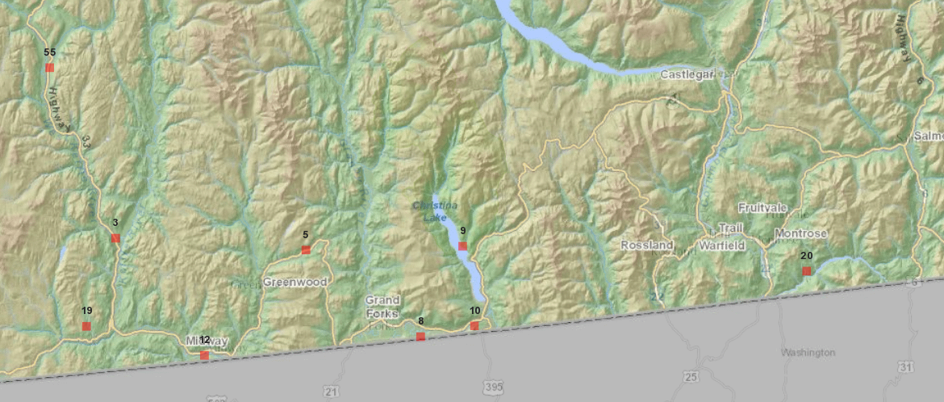
Figure 1. Location of West Kootenay/Boundary PSP’s.

Three Tree Beating Results
Following two years of positive beatings for IDT, no such larvae were observed at any of the 9 PSS’s (Table 1). However similar to 2018 defoliation of blue spruce was noted in Rock Creek, east to Greenwood, and in Midway; all on private property. Similar to 2018 western spruce budworm (IDW) was present at one site, down from 5 sites in 2017. Once again the highest numbers (68) were recorded at Johnstone Creek Road, where light defoliation occurred on mature trees, and moderate on the understorey (Figure 2). This PSP has historically had the frequent incidence and intensity of IDW.
There was a lower diversity and total number of defoliators than in 2018; 9 species in total compared to 11, and 81 larvae compared to 149 larvae. This lower diversity and numbers is undoubtedly due to the cooler and wetter early summer. Western hemlock looper larval counts increased at the Beaverdell site in 2019, up to 23 from 9 in 2018.
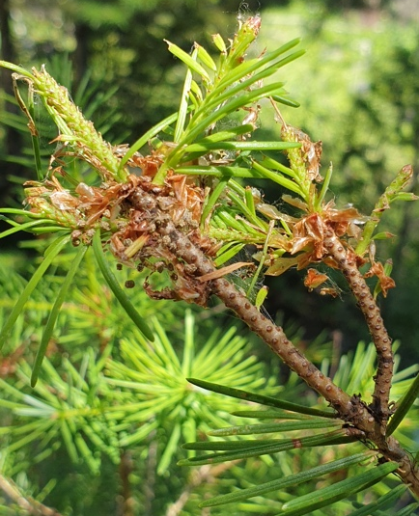
Figure 2. Western spruce budworm feeding damage, Johnstone Creek Road, west of Rock Creek.
Table 1. Larval counts for 9 PSP’s in the West Kootenays/ Boundary area as determined by three-tree beatings, 2019.
PSS | Date | Location | Choristoneura occidentalis | Orgyia pseudotusgata | Lambdina f. lugubrosa | Nepytia freemani | Cladara limitaria | Anoplonyx laricivorus | Noctuidae | Melanolophia imitata | Neodiprion spp. | Eupithecia spp | Feralia jacosa | Egira heimalis | Semiothisa sp | Tolype dayi | Nematocampa resistaria | Defoliation
2 | 1-Jul-19 | Johnstone Crk Rd | 36 |  | 3 |  |  | 2 |  | 1 | 1 | 1 |  |  |  |  |  | L from IDW
3 | 2-Jul-19 | Harrison Main* |  |  |  |  |  |  |  | 3 |  | 1 | 1 |  |  |  |  | NIl
5 | 1-Jul-19 | Eholt |  |  | 1 |  |  |  |  |  | 1 |  |  |  |  |  |  | NIl
8 | 1-Jul-19 | Grand Forks | 0 |  |  |  |  |  |  |  |  |  |  |  |  |  |  | NIl
9 | 1-Jul-19 | Texas Crk |  |  | 1 |  |  |  |  | 1 |  |  |  |  |  |  |  | NIl
10 | 1-Jul-19 | Cascades |  |  |  |  |  |  |  | 1 |  |  |  |  |  |  |  | NIl
12 | 1-Jul-19 | Midway |  |  |  |  |  |  |  | 1 | 1 |  |  |  |  |  |  | NIl
20 | 1-Jul-19 | Waneta |  |  |  | 1 |  |  |  |  |  |  |  |  |  |  |  | NIl
55 | 2-Jul-19 | Wallace Road |  |  | 23 |  |  |  |  |  |  |  |  |  | 1 |  |  | NIl
 |  | TOTAL | 36 | 0 | 28 | 1 | 0 | 2 | 0 | 7 | 3 | 2 | 1 | 0 | 1 | 0 | 0 | 81

Trap Results
While the average number of moths caught increased overall (5.3 from 2.3), three plots were negative for IDT unlike 2018 when all traps were positive (Table 2, Figure 4). The average number of moths per positive site was up from 2.3 in 2018 to 8.5 in 2019. Overall, including negative sites, the average trap count was 5.3. For the second consecutive year the area with the highest count is north of Kettle Creek Recreation area at Harrison Main with an average trap catch of 10.8, up from 6.8 in 2018.
Small numbers of pine tussock moth, Dasychira grisefacta, were also noted (Figure 3) as well as 1 western hemlock looper, Lambdina f. lugubrosa.
Table 2. (Average) trap catches from 9 PSP’s in the West Kootenays/Boundary area, 2019.
PSS | Location | 1 | 2 | 3 | 4 | 5 | 6 | Total | Avg | Other*
2 | Johnstone Creek Rd | 5 | 7 | 18 | 13 | down | missing | 43 | 10.8 | 1 PTM, 1 WHL
3 | Harrison Main | 12 | 20 | 9 | 26 | 16 | down | 83 | 13.8
5 | Eholt | 0 | 0 | 0 | 0 | 0 | 0 | 0 | 0.0
8 | Grand Forks | Traps all gone.
9 | Christina Lake | 0 | 1 | 0 | 1 | 0 | 0 | 1 | 0.2 | 8 PTM
10 | Cascades | 0 | 0 | 0 | 0 | 0 | 0 | 0 | 0.0
12 | Midway | down | down | 13 | 13 | 10 | 0 | 36 | 14.4
20 | Waneta | 0 | 0 | 0 | 0 | 0 | 0 | 0 | 0.0 | 2 PTM
55 | Wallace Road | 0 | 3 | 5 | 2 | 5 | 4 | 19 | 3.2 | 4 PTM
Avg |  |  |  |  |  |  |  |  | 5.3
* PTM = pine tussock moth, RTM = rusty tussock moth, WHL = western hemlock looper
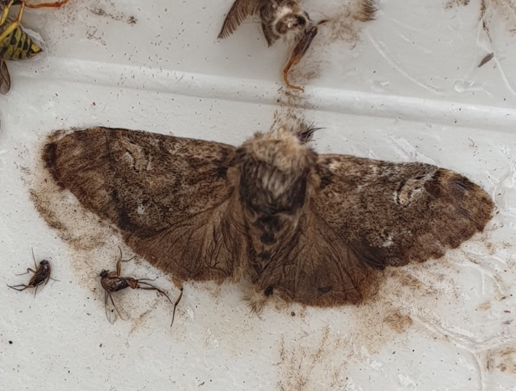
Figure 3. Pine tussock moth, Dasychira grisefacta, in trap at Texas Creek.

Figure 4. Douglas-fir tussock moth pheromone trap catches from 2009-2019 for 8 (Grand Forks traps all missing) monitoring sites in the West Kootenay/Boundary area.

Other Noteworthy Pests
Similar to 2018 Douglas-fir bark beetle and drought were the dominant visible disturbances in the study area in 2019. Most notable were lodgepole pine stands on dry knolls in the Salmo-Creston pass and in the Boundary area (Figure 5). As in previous years, Douglas-fir bark beetle combined with root disease is likely playing a role in ongoing Douglas-fir single tree scattered mortality between Grand Forks and Eholt. Serpentine leaf miner was ubiquitous throughout the host range.
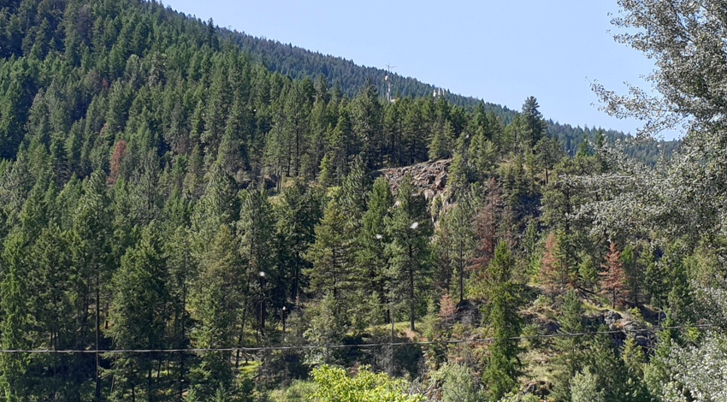
Figure 5. Drought mortality to Douglas-fir on dry site west of Grand Forks.

